Contents
Struts1 Execution flow Diagram 2
Struts2 Execution Flow Diagram 3
Comparison of Struts 1 and Struts 2 5
Component differences 5
Functional Differences 6
Struts 2 Aware Interfaces Tutorial 7
What design patterns are used in Struts 1.X? 7
Which design pattern follow by struts 2.0? 8
What is difference between Redirect and Redirect Action result type in struts 2 ? 8
Which interceptor is responsible for i18n support? 9
What is the use of execAndWait interceptor? 9
What is the use of token interceptor in Struts2? 9
What are different Struts2 tags? How can we use them? 9
What is life cycle of an interceptor? 10
What is an interceptor stack? 10
What is the default suffix for Struts2 action URI and how can we change it? 10
What is the default location of result pages and how can we change it? 10
How can we upload files in Struts2 application? 10
How can we handle exceptions thrown by application in Struts2? 10

Struts1 Execution flow Diagram
Model : Models in Struts 1 framework are the java bean classes that extends ActionForm class provided in Struts jars. Model classes holds the state of the internal and external system.
View : Views are web components that are shown to the web browser users. In Struts 1, it can be jsp page or any view render technique such as Tiles.
Controller : Controllers are the components that handles are the requests that comes from users and decides which view is to send back to the use as response. In Struts 1 the controller part is handled by ActionServlet class and a subclass of Action class that is developer defined. The controller may interact with the application specific business logic or some code that persists data in database or with an EJB.
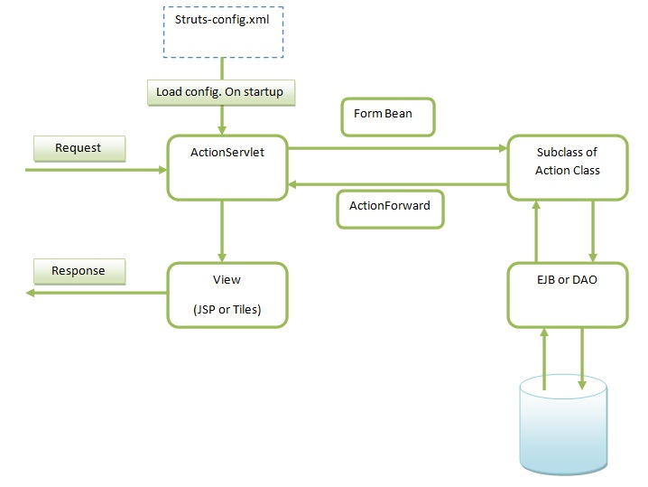
1. When first time user request comes from the browser, ActionServlet invoked which reads struts-config.xml configuration file and creates configuration objects. struts-config.xml contains information about the FormBeans, that are subclasses of ActionForm, Actions and view that can be send as response to the browser.
2. In the second step ActionServlet instantiate the specified form bean and puts the value of the form attributes, submitted by the browser, to form bean.
3. Then ActionServlet calls the Action class’s execute method, which returns ActionForward instance. ActionForward instance contains the detail of the view to be return as response.
4. ActionServlet renders the view and return to the browser as response.

Struts2 Execution Flow Diagram
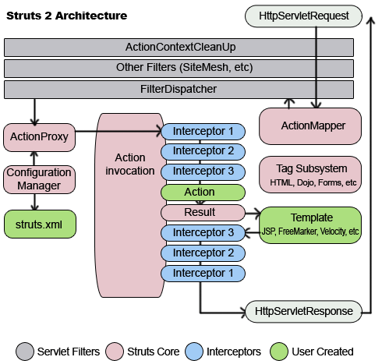
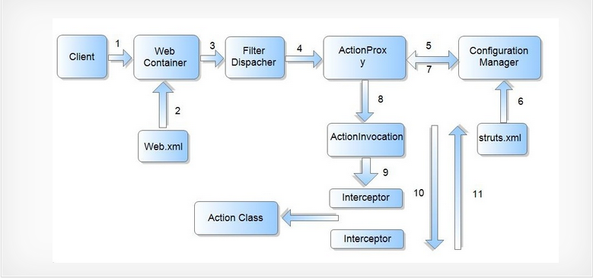
a) The flow starts with the web browser placing a request for a particular resource.
b) This request is received by the web container. The container loads web.xml and checks if the url patterns match. If it matches, the web container transfers the request to Filter Dispatcher.
c) The Filter Dispatcher decides the suitable action, by calling the ActionMapper, which in turn calls the ActionProxy.
d) ActionProxy reads the configuration file such as struts.xml, and finds the suitable action for the request. ActionProxy creates an instance of ActionInvocation class.
e) The ActionInvocation class invokes the Interceptors one by one (if required).The Interceptors use the required functions and after that, the Action method executes all the functions like storing and retrieving data from a database. ActionInvocation receives the final result produced by an action class.
Once the Action returns, the ActionInvocation is responsible for looking up the proper result associated with the Action result code mapped in struts.xml. The Interceptors are executed again in reverse order and the response is returned from ActionProxy to the Filter (In most cases to FilterDispatcher).
f) FilterDispatcher selects an appropriate view, basing on the result. The result is then sent to the servlet container which in turn sends it back to the client.
Then the result can be seen on the output of the browser in HTML, PDF, images or any other format.
The other important features of Struts 2 are ValueStack & OGNL.
Object-Graph Navigation Language (OGNL) is a powerful expression language that is used to reference and manipulate data on the ValueStack. OGNL expression language provides simplified syntax to reference java objects. It helps in data transfer and type conversion by binding the java-side data properties to the string-based view layer.
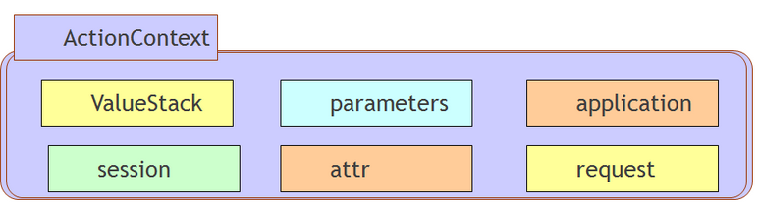
1) In Struts 2 the action resides on the ValueStack which is a part of the ActionContext.
2) ActionContext is a global storage area that holds all the data associated with the processing of a request.
3) When a request comes the param interceptor helps in moving the request data to the ValueStack.
4) Now the OGNL does the job of converting the string based form data to their corresponding java types. OGNL does this by using the set of available built-in type converters.Again when the results are generated the OGNL converts the java types of the property on the ValueStack to the string-based HTML output.
Here for N number of request N number of object is created, this makes the Struts 2 actions not thread safe.

Comparison of Struts 1 and Struts 2

Component differences
- In struts 1.x front controller is ActionServlet
In struts2.x front controller is FilterDispatcher

- In struts 1.x we have RequestProcessor class
In 2.x we have Interceptors instead RequestProcessor

- In struts 1.x we have multiple tag libraries like, html, logic, bean..etc
In 2.x do not have multiple libraries, instead we have single library which includes all tags
- Struts 1 and Struts 2 is on configuration files, earlier we used to configure Struts using struts-config.xml, but with Struts 2 most commonly used as struts.xml

- In struts 1.x we have form beans and Action classes separately
In 2.x form bean, Action classes are combined given as Action class only, of course we can take separately if we want

- In struts 1.x properties file must be configured in struts-config.xml
But in 2.x we need to configure our resource bundle(s) in struts.properties file

- In struts 1.x we have programmatic and declarative validations only
In 2.x we have annotations support too along with programmatic and declarative validations

Functional Differences
  - In struts 1.x declarative validations are done by using validation frame work
In 2.x, declarative validations are done by using xwork2 framework by webwork the reason being, its support valuations through Annotations

  - In struts 1.x an Action class is a single ton class, so Action class object is not a thread safe, as a programmer we need to make it as thread safe by applying synchronization
In 2.x an Action class object will be created for each request, so it is by default thread safe, so we no need to take care about safety issues here

  - In struts 1.x we have only jsp as a view technology
In 2.x we have support of multiple view technologies like velocity, Freemarker, jasper reports, jsp etc

  - In Struts 1 it's mandatory to extend org.apache.struts.action.Action and implement execute() method which returns ActionForward and accept HttpServletRequest and HttpServletResponse.
In Struts 2, here Action class can be a simple POJO or Java object with execute() method. Also execute() method returns String rather than returning ActionForward object. You can still use ActionSupport class or Action interface but those are completely optional.

  - Configurations in web.xml
In struts 1
<servlet>
<servlet-name>StrutsController</servlet-name>
<servlet-class>org.apache.struts.action.ActionServlet</servlet-class>
<init-param>
<param-name>config</param-name>
<param-value>/WEB-INF/struts-config1.xml, /WEB-INF/struts-config2.xml </param-value>
</init-param>
<load-on-startup>1</load-on-startup>
</servlet>
<servlet-mapping>
<servlet-name>StrutsController</servlet-name>
<url-pattern>*.do</url-pattern>
</servlet-mapping>

In Struts2

<filter>
<filter-name>DispatcherFilter</filter-name>
<filter-class>org.apache.struts2.dispatcher.ng.filter.StrutsPrepareAndExecuteFilter</filter-class>
</filter>
<filter-mapping>
<filter-name>DispatcherFilter</filter-name>
<url-pattern>/*</url-pattern>
</filter-mapping>
Note:
- For Struts 2 version < 2.1.3, the filter dispatcher is implemented by FilterDispatcher class.
org.apache.struts2.dispatcher.FilterDispatcher
- For Struts 2 version >= 2.1.3, it is recommended to use this dispatcher class: StrutsPrepareAndExecuteFilter, since is the FilterDispatcher class deprecated.
org.apache.struts2.dispatcher.ng.filter.StrutsPrepareAndExecuteFilter

- Struts 1 Actions have dependencies on the servlet API since the HttpServletRequest and HttpServletResponse is passed to the execute method when an Action is invoked. Struts 2 Actions are not coupled to a container. Most often the servlet contexts are represented as simple Maps, allowing Actions to be tested in isolation.

Struts 2 Aware Interfaces Tutorial

Aware Interfaces are use to make a struts 2 container dependent
Struts 2 Aware interfaces are used to put information into the request, response, context or session object.

The action class must implement these interfaces to store information so that it can be retrieved from other action class.
The four aware interfaces are:
- org.apache.struts2.interceptor.SessionAware
- org.apache.struts2.util.ServletContextAware
- org.apache.struts2.interceptor.ServletRequestAware
- org.apache.struts2.interceptor.ServletResponseAware

What design patterns are used in Struts 1.X?

- Struts controller uses the command design pattern
- Action classes use the Adapter design pattern.
- The Process () method of the RequestProcessor uses the template method design pattern.
Struts also implement the following J2EE design patterns.
  - Service to Worker,
  - Dispatcher View,
  - Composite View (Struts Tiles),
  - Front Controller, ( ActionServlet)
  - View Helper, (Tag Library)
  - Synchronizer Token

Which design pattern follow by struts 2.0?
- Struts controller uses the command design pattern
- Action classes use the Adapter design pattern.
- Context Object design pattern
- MVC
- Synchronizing Token
- Front Controller ( Filter Dispatcher or StrutsPrepareAndExecute)
- Intercepting Filter
- Composite View(Struts Tiles)
- View Helper(Tag Library)
- Application Controller ( Dispatcher Class)

What is difference between Redirect and Redirect Action result type in struts 2 ?
Main difference between redirect and redirect action is redirect use when we send redirect our control one url to another url we use redirect. And when we redirect our control one action to another action at this time we are use redirect action result type.
What is the advantage of extending the action class from ActionSupport class?
The use of ActionSupport class provides the features like validation, locale support and serialization to an action

What is the relation between ValueStack and OGNL ?
ValueStack is the storage area where the application data is stored by Struts2 for processing the client requests. The data is stored in ActionContext objects that use ThreadLocal to have values specific to the particular request thread.
Object-Graph Navigation Language (OGNL) is a powerful Expression Language that is used to manipulate data stored on the ValueStack. As you can see in architecture diagram, both interceptors and result pages can access data stored on ValueStack using OGNL.
Which interceptor is responsible for mapping request parameters to action class Java Bean properties?
com.opensymphony.xwork2.interceptor.ParametersInterceptor interceptor is responsible for mapping request parameters to the Action class java bean properties. This interceptor is configured in struts-default package with name “params”. This interceptor is part of basicStack and defaultStack interceptors stack.

Which interceptor is responsible for i18n support?
com.opensymphony.xwork2.interceptor.I18nInterceptor interceptor is responsible for i18n support in Struts2 applications. This interceptor is configured in struts-default package with name “i18n” and it’s part of i18nStack and defaultStack.

What is the use of execAndWait interceptor?
Struts2 provides execAndWait interceptor for long running action classes. We can use this interceptor to return an intermediate response page to the client and once the processing is finished, final response is returned to the client. This interceptor is defined in the struts-default package and implementation is present in ExecuteAndWaitInterceptor class.

What is the use of token interceptor in Struts2?
One of the major problems with web applications is the double form submission. If not taken care, double form submission could result in charging double amount to customer or updating database values twice. We can use token interceptor to solve the double form submission problem. This interceptor is defined in struts-default package but it’s not part of any interceptor stack, so we need to include it manually in our action classes.

What are different Struts2 tags? How can we use them?
Struts2 provides a lot of custom tags that we can use in result pages to create views for client request. These tags are broadly divided into three categories- Data tags, Control tags and UI tags.
We can use these tags by adding these in JSP pages using taglib directive.
<%@ taglib uri="/struts-tags" prefix="s" %>
Some of the important Data tags are property, set, push, bean, action, include, i18n and text tag.
Control tags are used for manipulation and navigation of data from a collection. Some of the important Control tags are if-elseif-else, iterator, append, merge, sort, subset and generator tag. Read more at Struts2 Control Tags.
Struts2 UI tags are used to generate HTML markup language, binding HTML form data to action classes properties, type conversion, validation and i18n support. Some of the important UI tags are form, textfield, password, textarea, checkbox, select, radio and submit tag. Read more about them at Struts2 UI Tags.

What is life cycle of an interceptor?
Interceptor interface defines three methods – init(), destroy() and intercept(). init and destroy are the life cycle methods of an interceptor. Interceptors are Singleton classes and Struts2 initialize a new thread to handle each request. init() method is called when interceptor instance is created and we can initialize any resources in this method. destroy() method is called when application is shutting down and we can release any resources in this method.
intercept() is the method called every time client request comes through the interceptor.

What is an interceptor stack?
An interceptor stack helps us to group together multiple interceptors in a package for further use. struts-default package creates some of the mostly used interceptor stack – basicStack and defaultStack. We can create our own interceptor stack at the start of the package and then configure our action classes to use it.

What is the default suffix for Struts2 action URI and how can we change it?
The default URI suffix for Struts2 action is .action, in Struts1 default suffix was .do. We can change this suffix by defining struts.action.extension constant value in our Struts2 configuration file as:
<constant name="struts.action.extension" value="action,do"></constant

What is the default location of result pages and how can we change it?
By default Struts2 looks for result pages in {WEBAPP-ROOT}/{Namespace}/ directory but sometimes we want to keep result pages in another location, we can provide struts.convention.result.path constant value in Struts2 configuration file to change the result pages location.
Another way is to use @ResultPath annotation in action classes to provide the result pages location.

How can we upload files in Struts2 application?
File Upload is one of the common task in a web application. Thats why Struts2 provides built in support for file upload through FileUploadInterceptor. This interceptor is configured in struts-default package and provide options to set the maximum size of a file and file types that can be uploaded to the server

How can we handle exceptions thrown by application in Struts2?
Struts2 provides a very robust framework for exception handling. We can specify global results in packages and then map specific exceptions to these result pages. The exception mapping can be done at the global package level as well as action level.
It’s a good idea to have exception result pages to provide some information to user when some unexpected exception occurs that is not processed by the application. Sample configuration in struts.xml file looks like below.
<package name="user" namespace="/" extends="struts-default">

<global-results>
<result name="exception">/exception.jsp</result>
<result name="runtime_exception">/runtime_exception.jsp</result>
<result name="error">/error.jsp</result>
</global-results>

<global-exception-mappings>
<exception-mapping exception="java.lang.Exception" result="exception"></exception-mapping>
<exception-mapping exception="java.lang.Error" result="error"></exception-mapping>
<exception-mapping exception="java.lang.RuntimeException" result="runtime_exception"></exception-mapping>
</global-exception-mappings>

<action name="myaction" class="com.journaldev.struts2.exception.MyAction">
</action>
<action name="myspecialaction" class="com.journaldev.struts2.exception.MySpecialAction">
<exception-mapping exception="java.io.IOException" result="login"></exception-mapping>
<result name="login">/error.jsp</result>
</action>
</package>

